CENWP-OD-B 11 July 2022
MEMORANDUM FOR THE RECORD
SUBJECT: 22BON034 MFR WA-AWS LPS Pacific Lamprey Mortality

On the morning of 11 July, Bonneville Fisheries discovered one adult Pacific Lamprey mortality in Rest Box 1 of the Washington Shore Auxiliary Water Supply Lamprey Passage Structure (WA-AWS LPS). The fish was scanned for PIT tags, inspected, and returned to the river.

- Species – (Entosphenus tridentatus)
- Origin – Unknown
- Length – Approximately 72.4 cm
- Marks and tags – None
- Marks and Injuries found on carcass – None
- Cause and Time of Death – Unknown
- Future and Preventative Measures – None
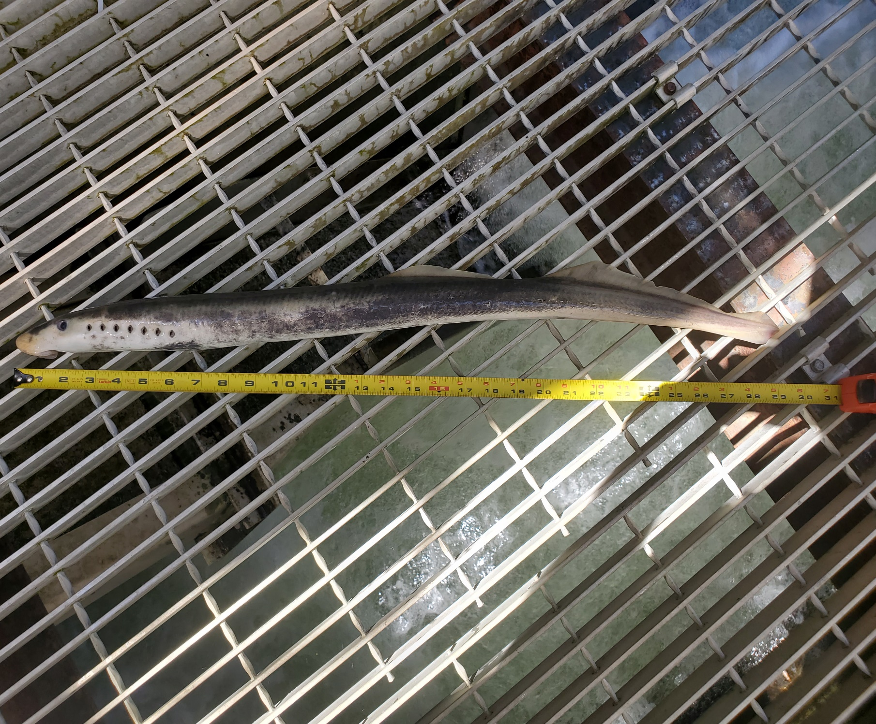

Sincerely,
Bonneville Project Fisheries

